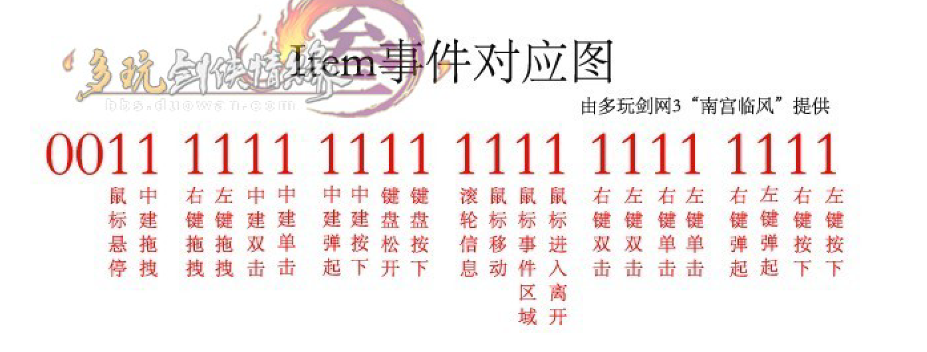

|  |  |
| --- | --- |
| Vị trí | Ý nghĩa |
| 0 | Left button hold |
| 1 | Right button hold |
| 2 | Left button up |
| 3 | Right button up |
| 4 | Left button down |
| 5 | Right button down |
| 6 | Left button double click |
| 7 | Right button double click |
| 8 | Mouse hover and mouse leave event |
| 9 | Mouse event |
| 10 | Mouse move |
| 11 | Mouse wheel |
| 12 | Key hold |
| 13 | Key up |
| 14 | Mid button hold (mouse) |
| 15 | Mid button mouse up (mouse) |
| 16 | Mid button mouse down (mouse) |
| 17 | Mid button double click (mouse) |
| 18 | Left button drag |
| 19 | Right button drag |
| 20 | Mid button drag |
| 21 | Mouse stop |